Name: Mrs. Rupali N Hosmani.

Course: Executive Post Graduate Certification in Cloud Computing

Contact No. 7720003531

**Assignment 4: VPC & Peering**

**Task to be performed:**

**Production Network:**

1. Design and build a 4-tier architecture.

2. Create 5 subnets out of which 4 should be private named app1, app2, dbcache and db and one should be public, named web.

3. Launch instances in all subnets and name them as per the subnet that they have been launched in.

4. Allow dbcache instance and app1 subnet to send internet requests.

5. Manage security groups and NACLs.

**Development Network**:

1. Design and build 2-tier architecture with two subnets named web and db and launch instances in both subnets and name them as per the subnet names.

2. Make sure only the web subnet can send internet requests.

3. Create peering connection between production network and development network.

4. Setup connection between db subnets of both production network and development network respectively

**Step 1**: Designing of 4 tier Production Network & 2 tier Development Network with peering connection.

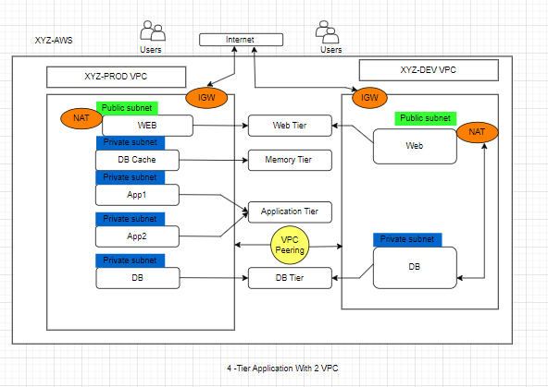

**Step 2: Production VPC**:

1.Create production VPC ,Subnets, IGW, NAT & route tables using VPC & MORE option:

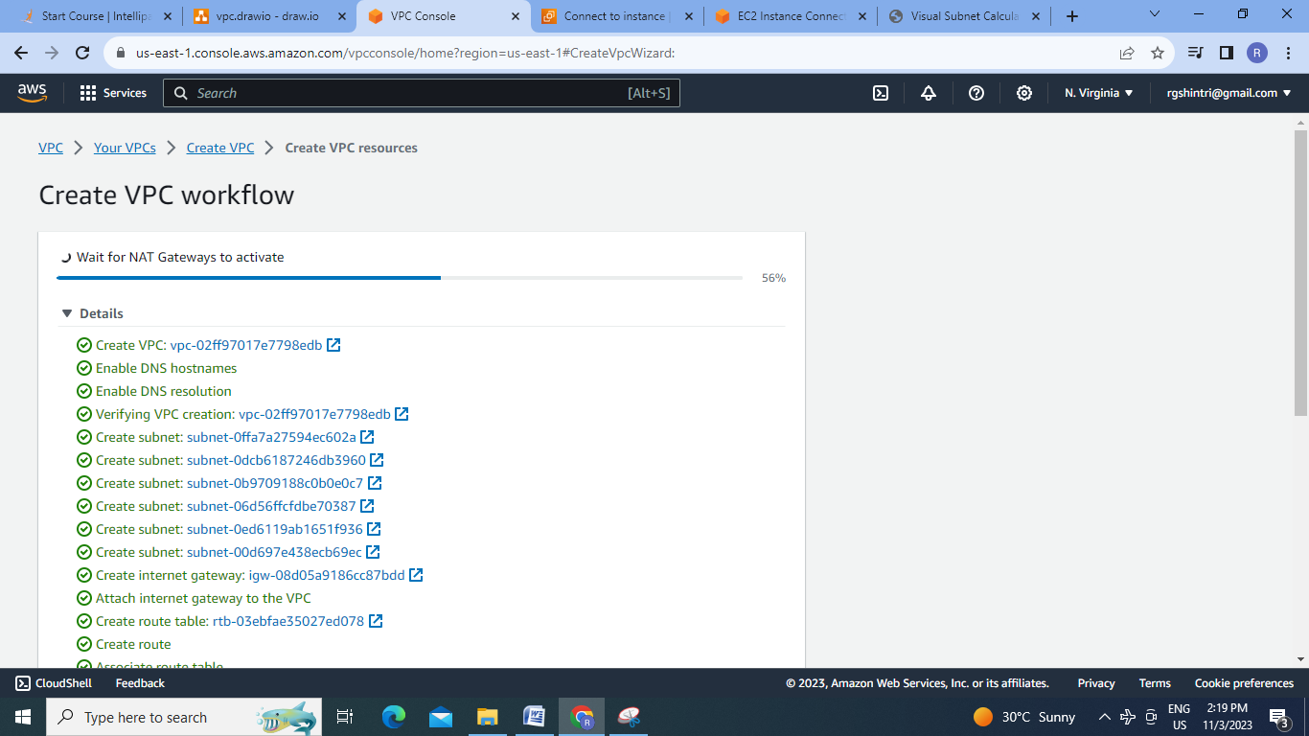

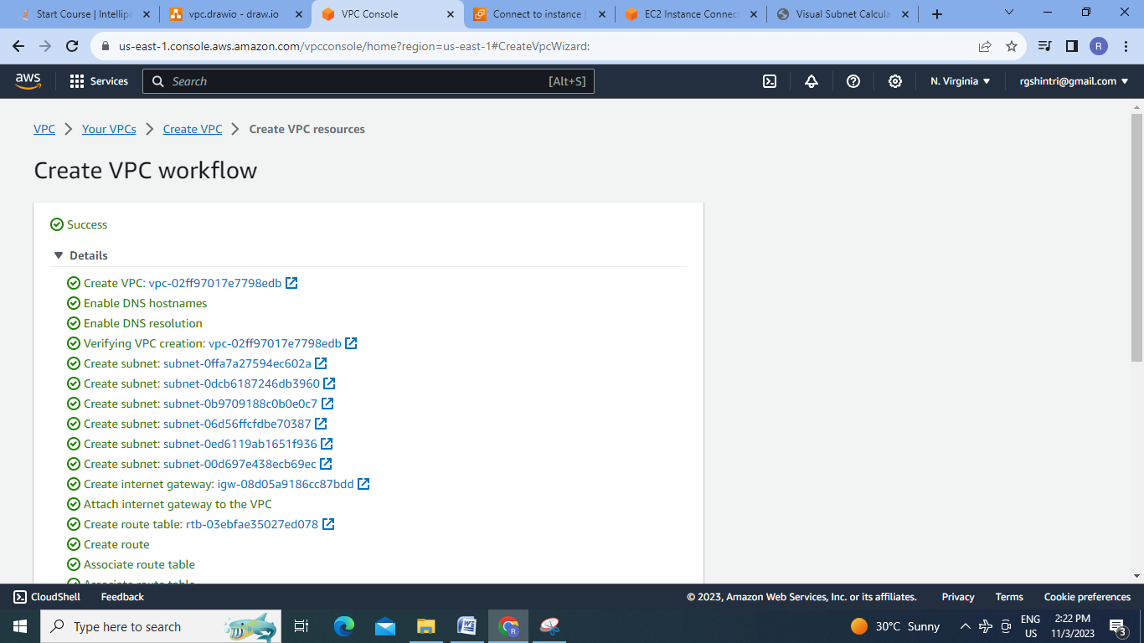

2.Delete unwanted resources like extra public subnet, routes:

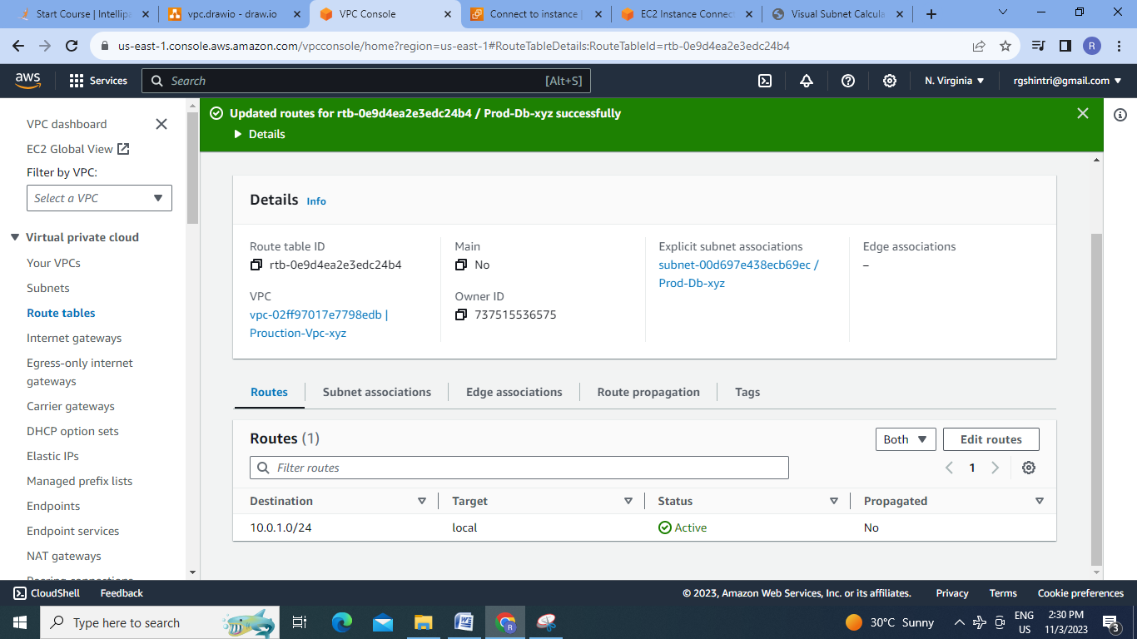

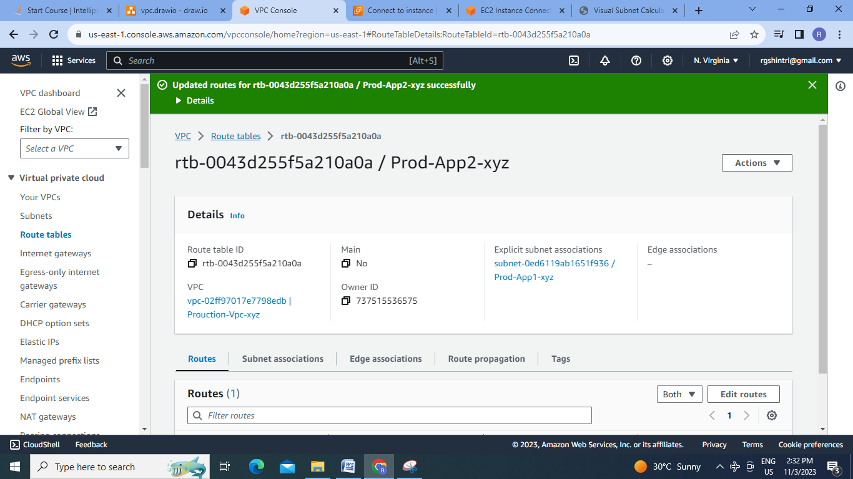

3.Final Production VPC:

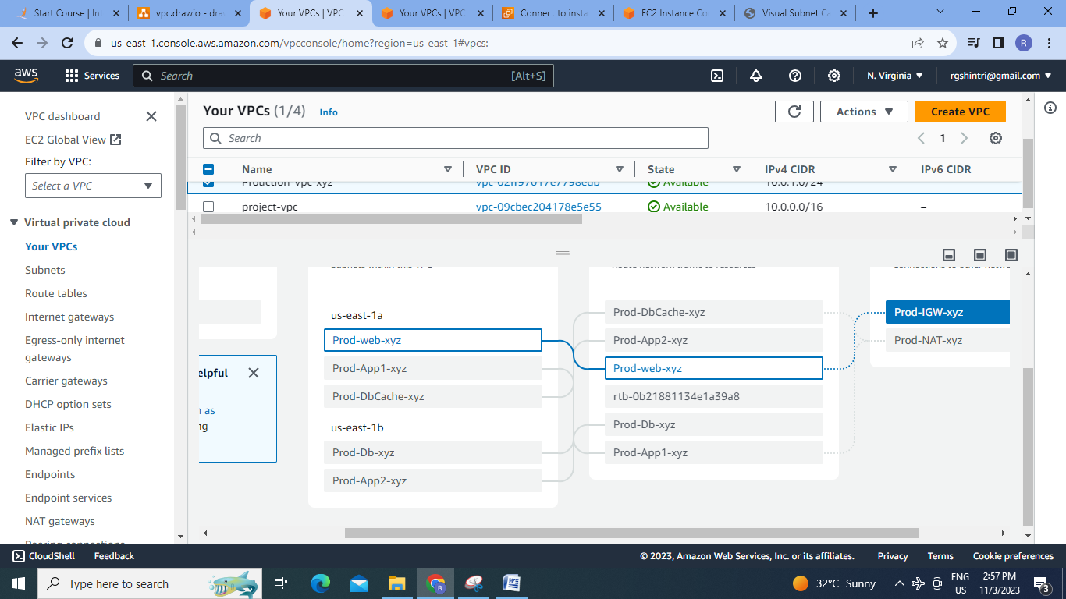

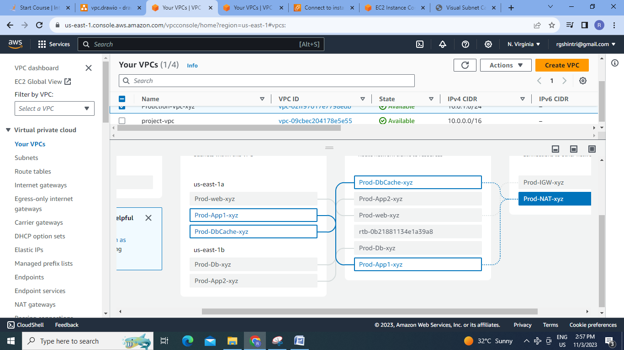

4.Testing of Production VPC:

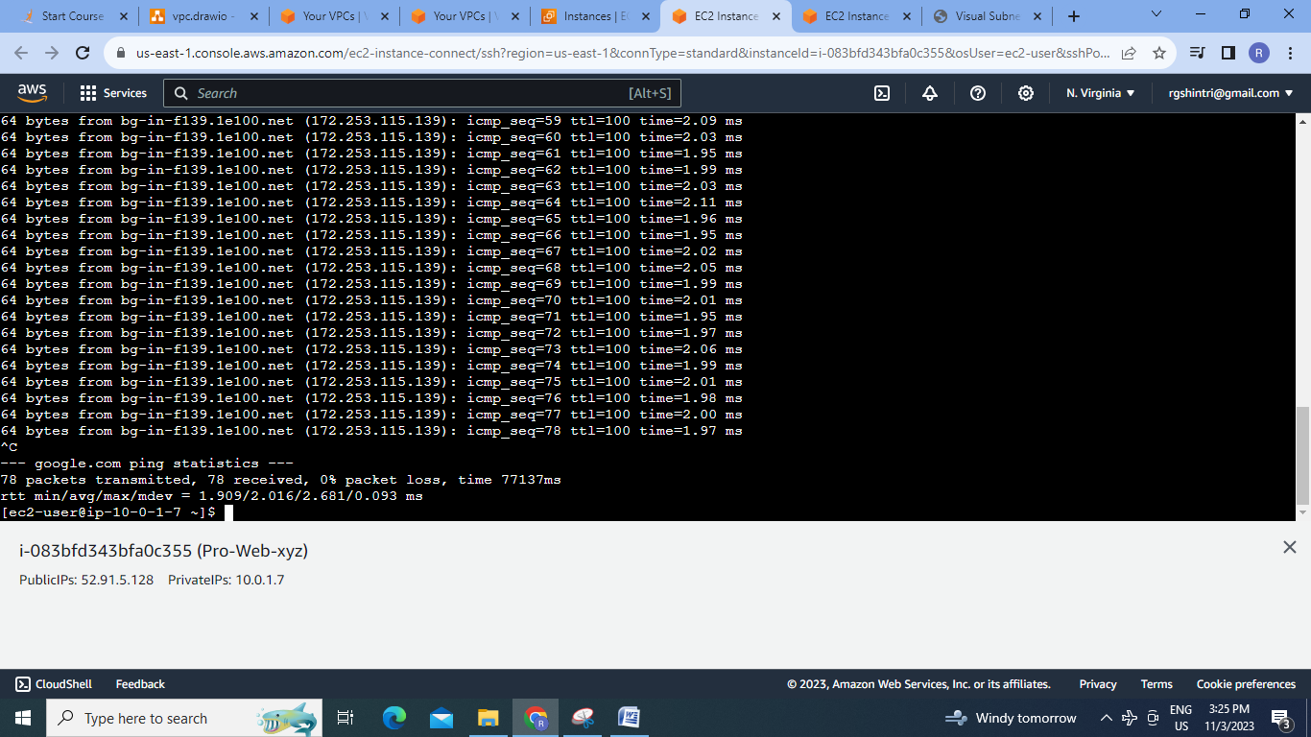

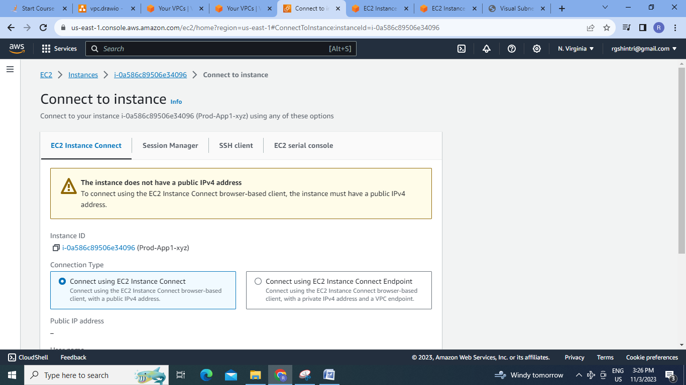

**Step 3:Development VPC**

1. Create Development VPC:

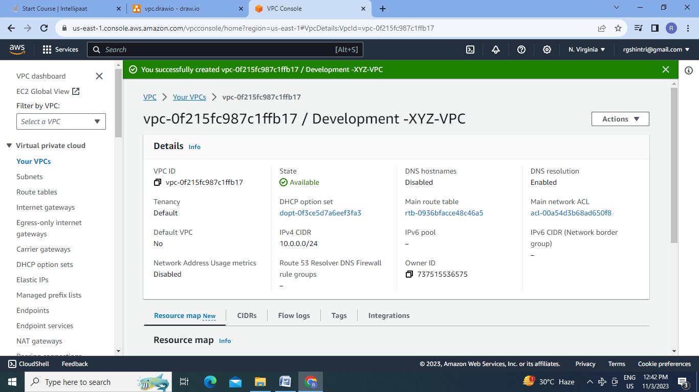

2. Create subnets:

Subnet CIDR calculator

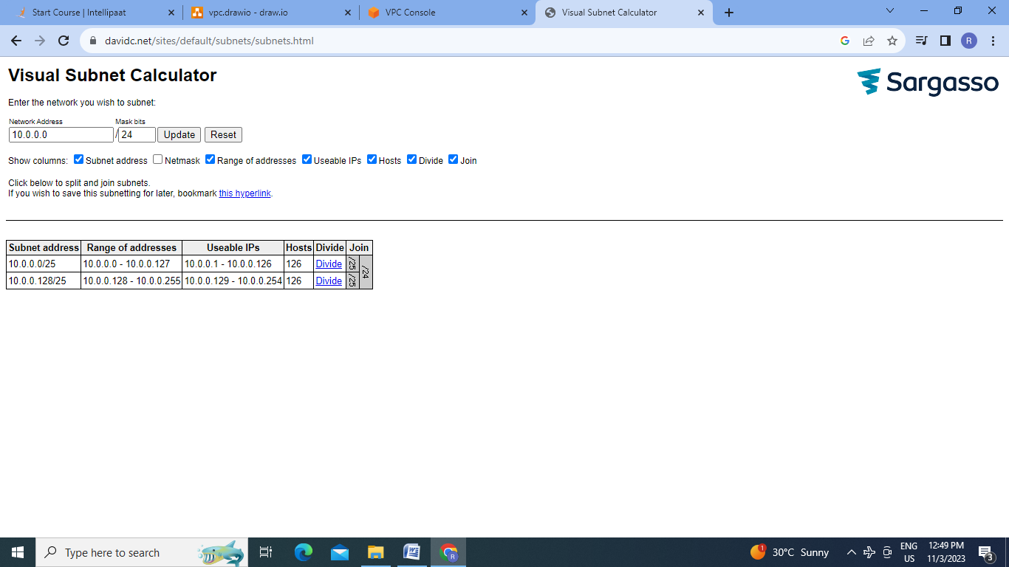

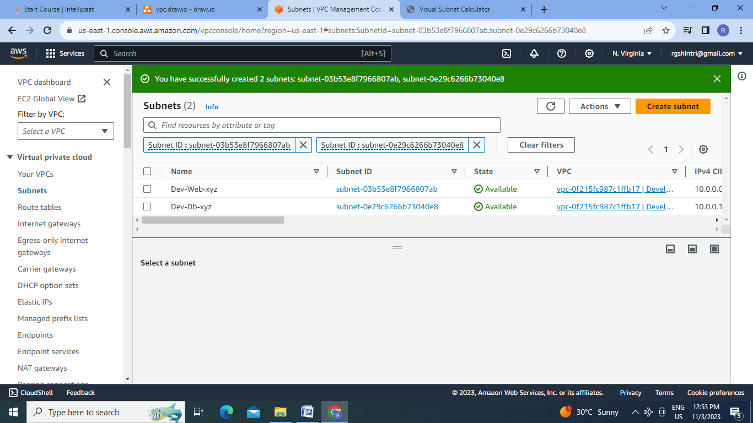

3.Enable auto-assign public IPv4 & create IGW for web subnet to make it public :

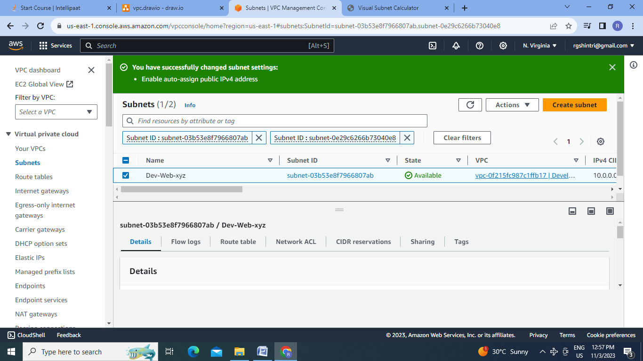

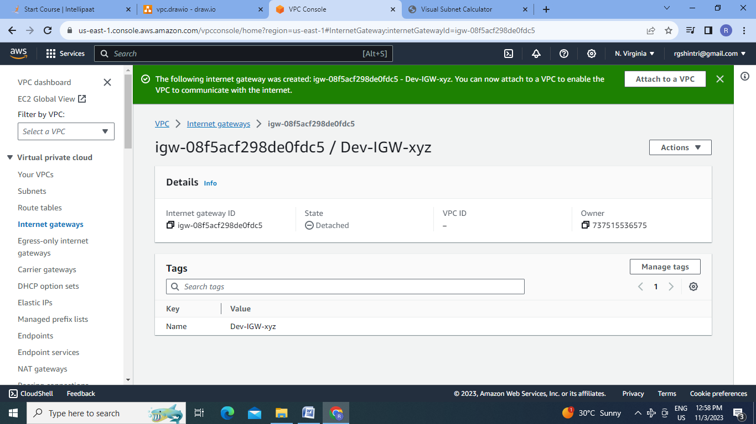

4.Attach IGW to VPC:

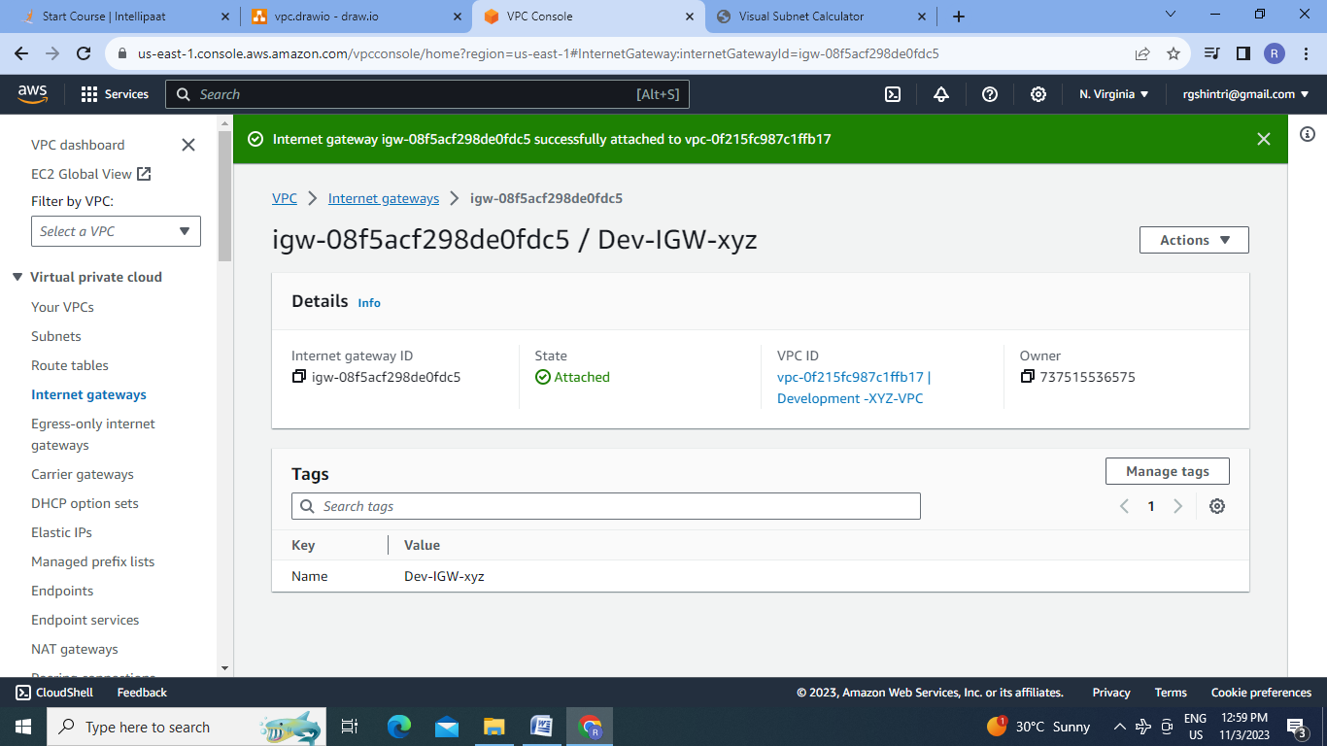

5.Create Routes & Route table:

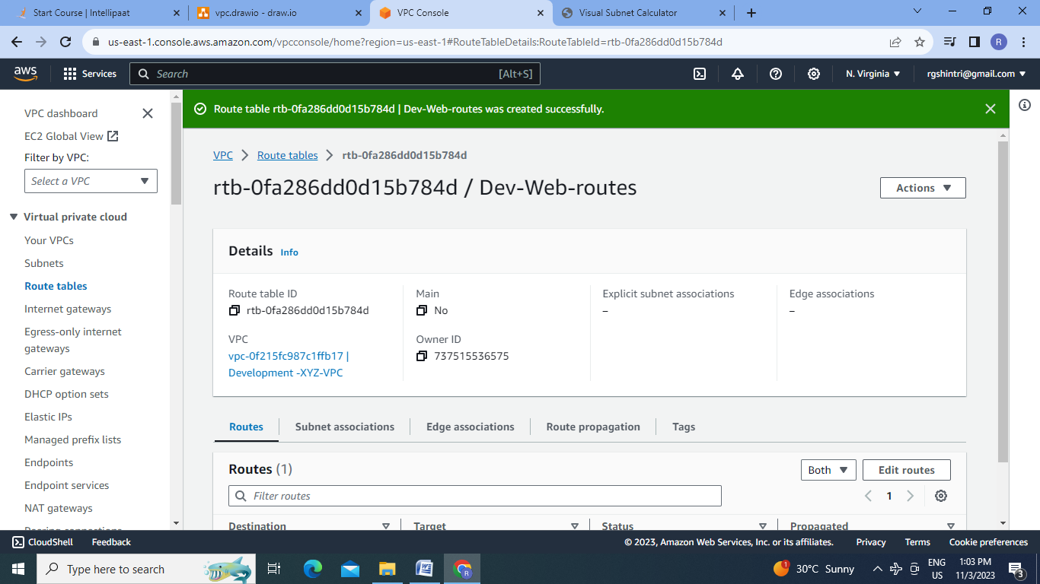

6.Test this VPC by creating EC2 instance in this DEV-web subnet & Dev-DB subnet:

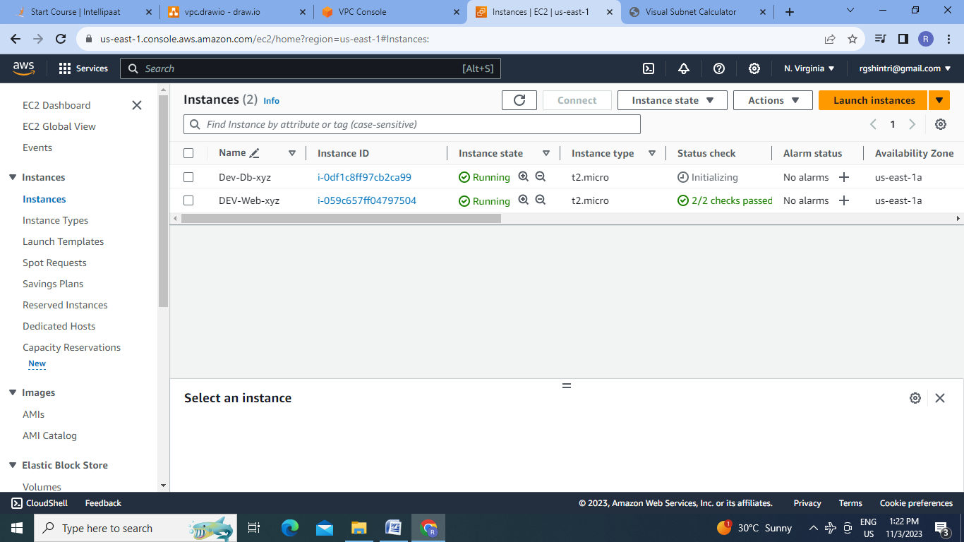

7.Able to connect to Web EC2 as it is public, but not to Db EC2:

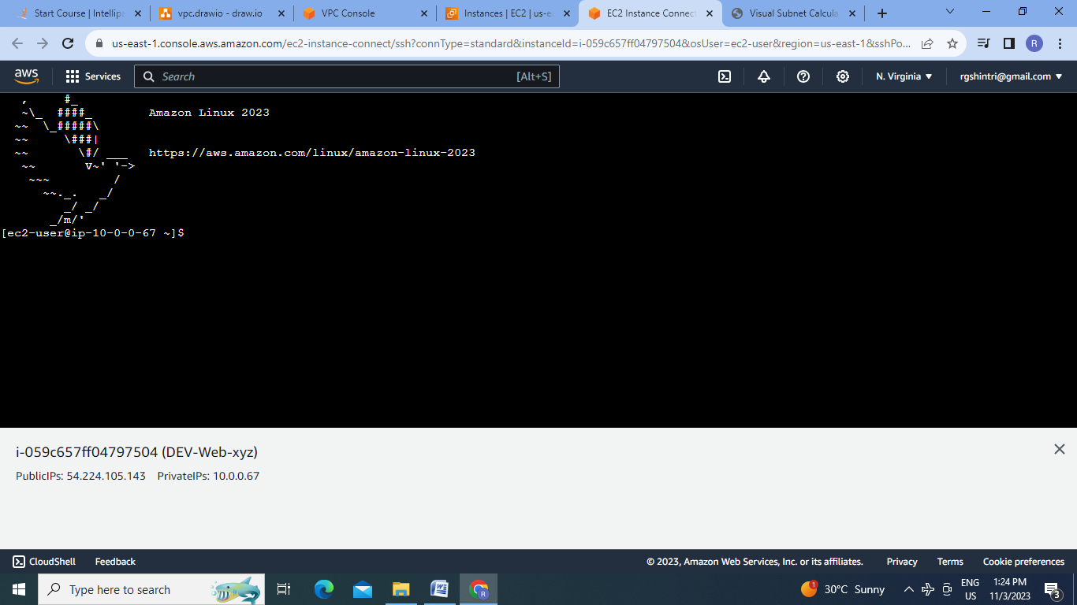

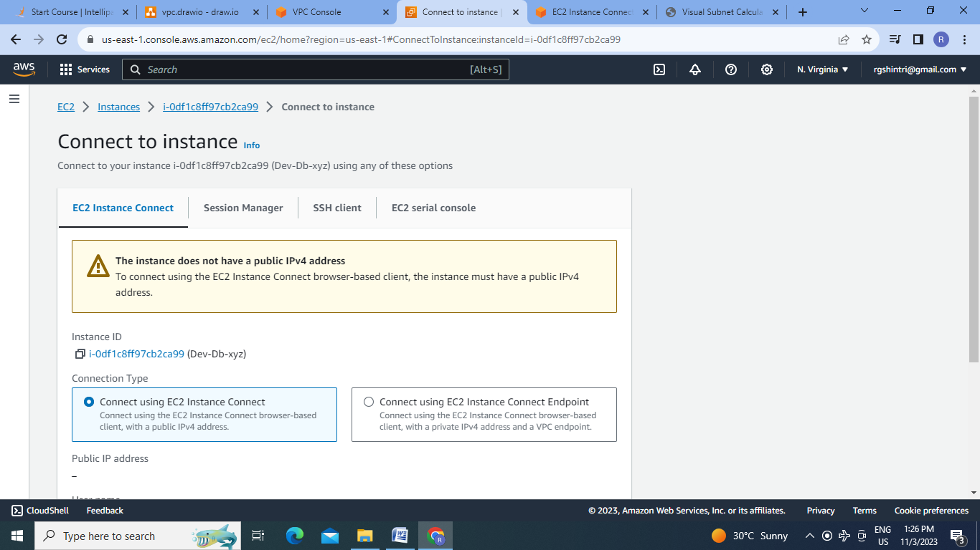

8. Create NAT Gateway:

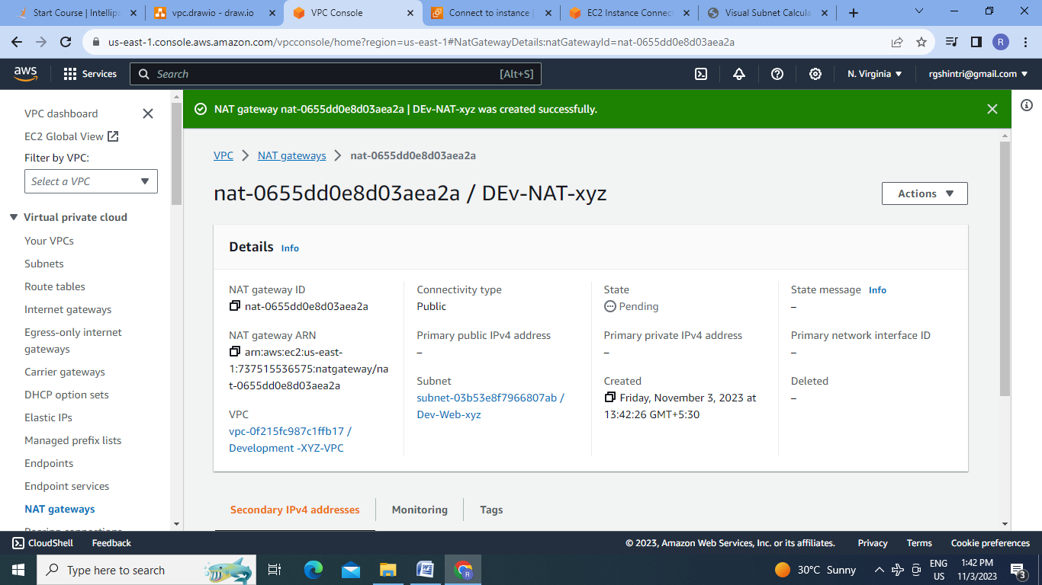

9.Create Route Table for DB Instance:

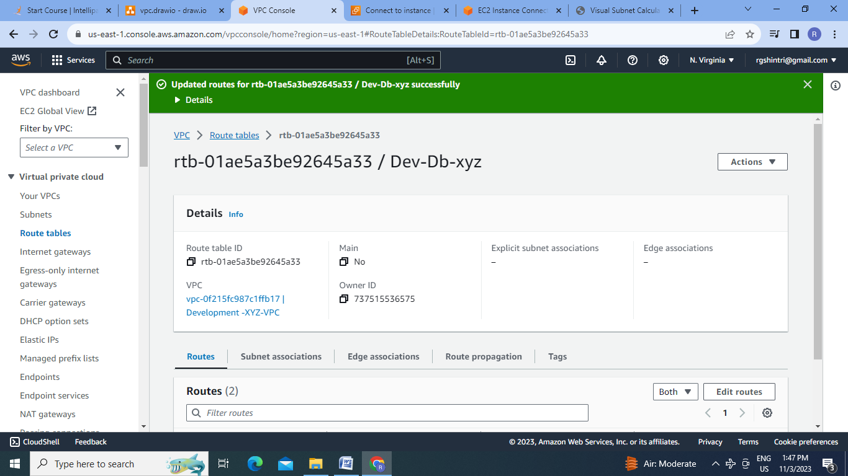

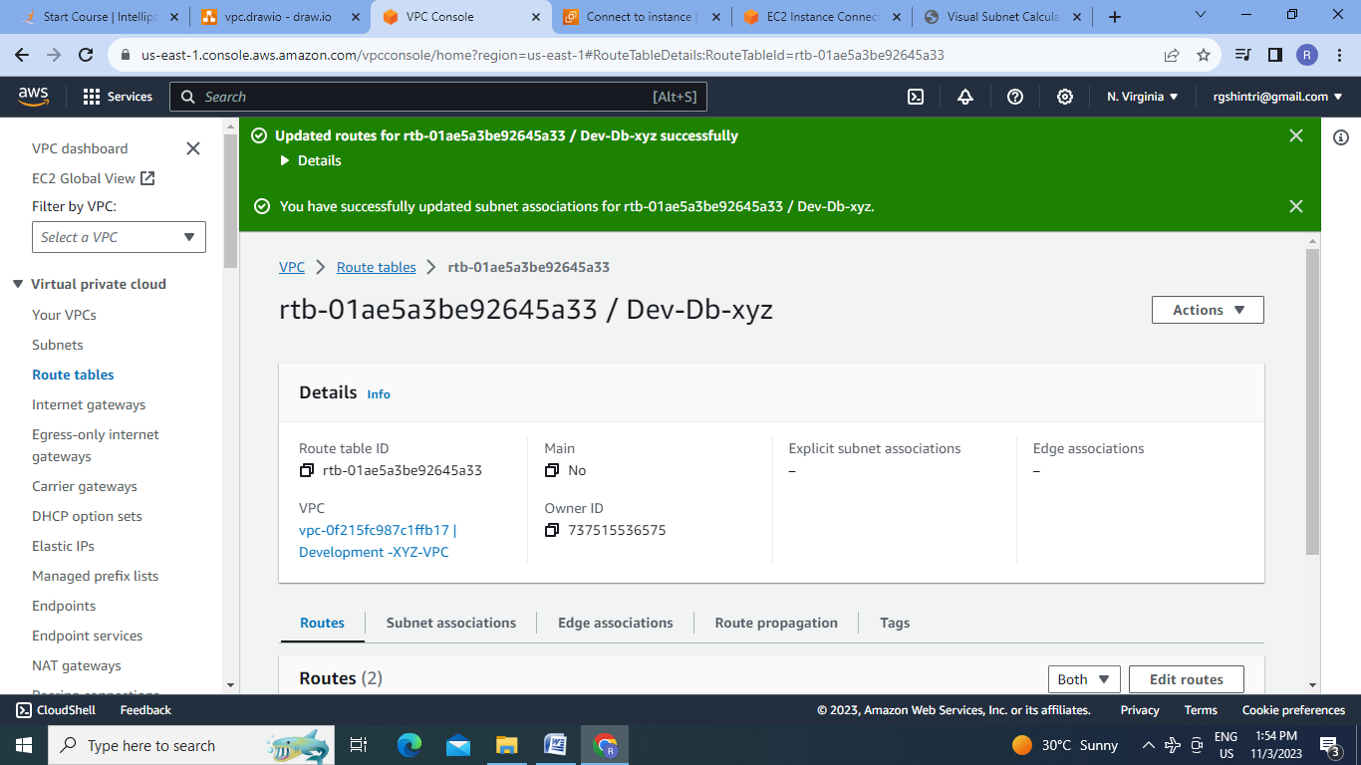

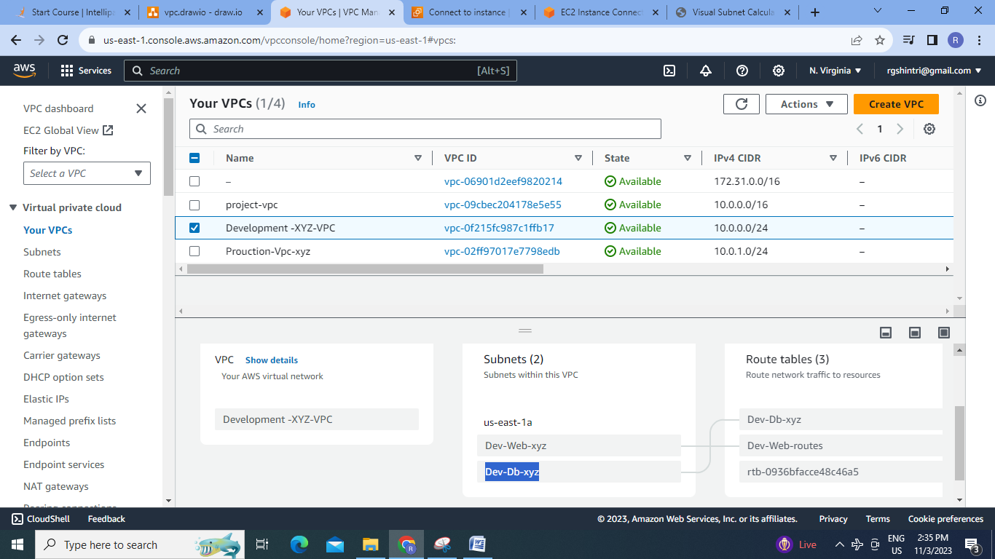

**Step4:Creating Peering Connection** :

1.create peering connection

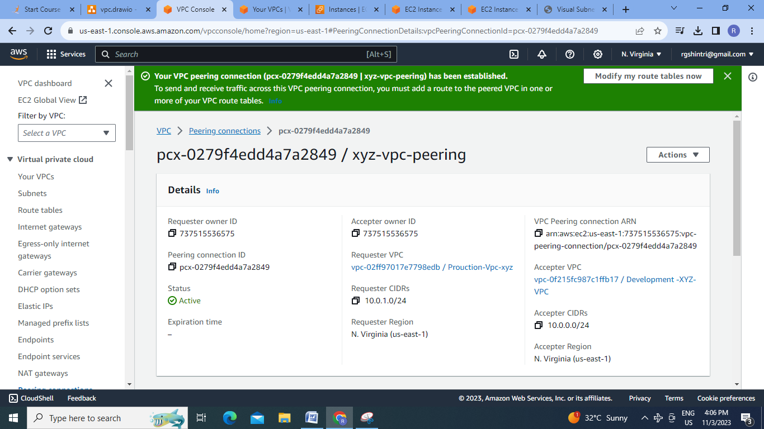

2.Define routes:

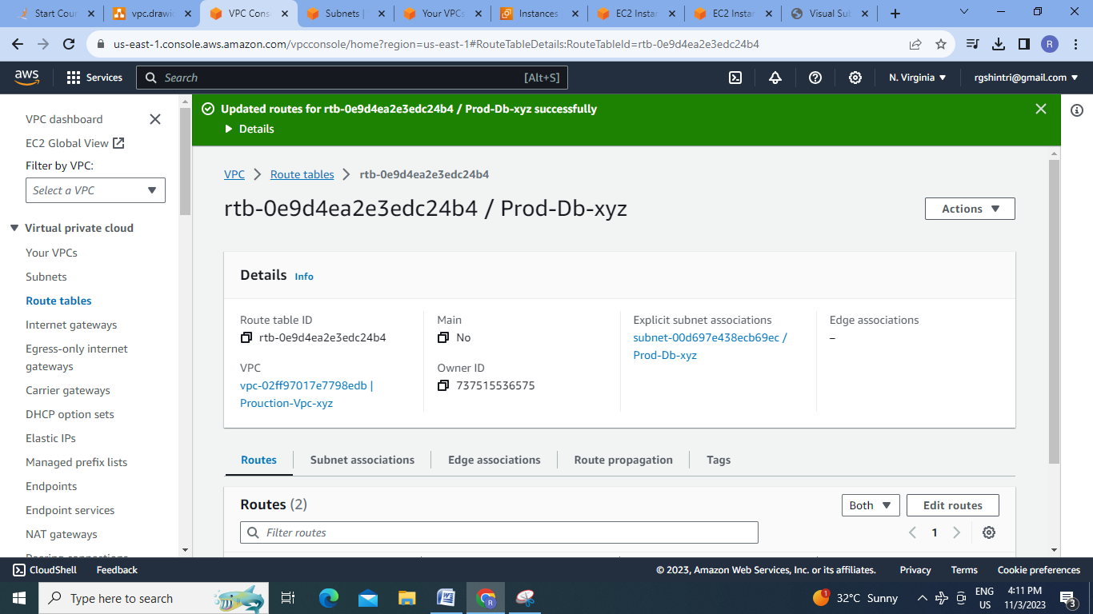

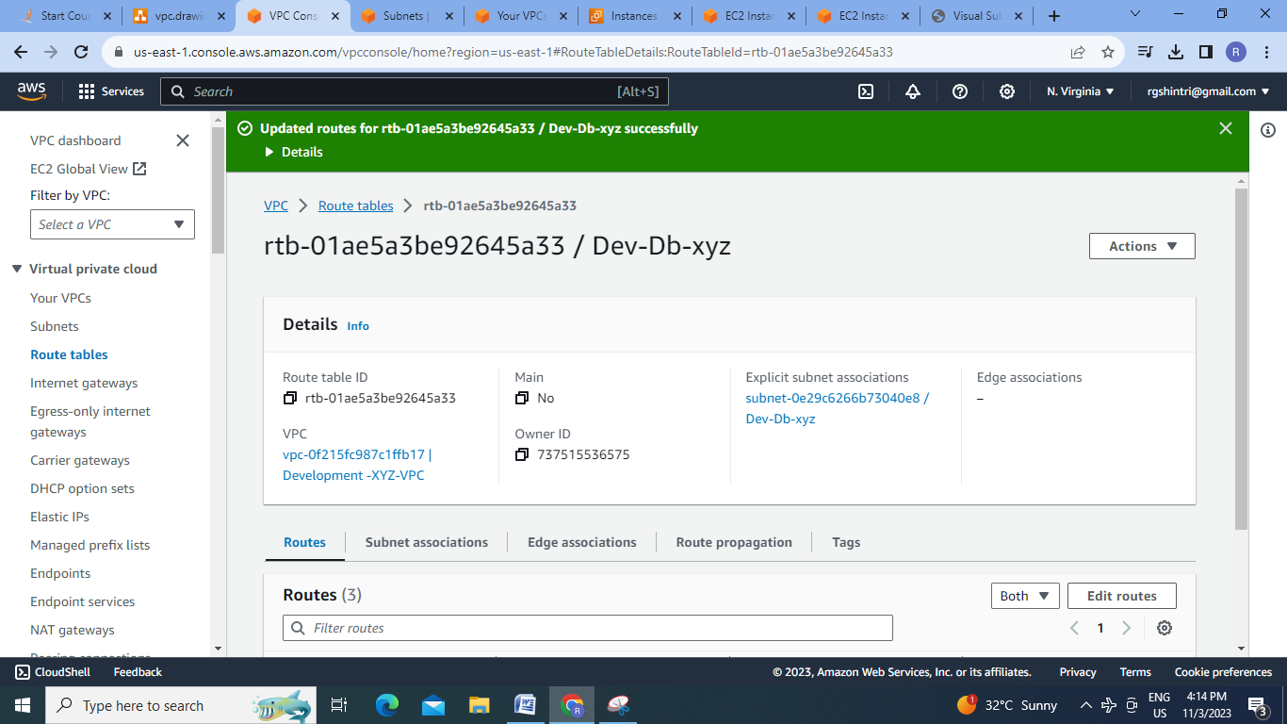

3.Check for Peering of Prod-db (Private IP:10.0.1.185)to dev-db(Private IP:10.0.0.219):

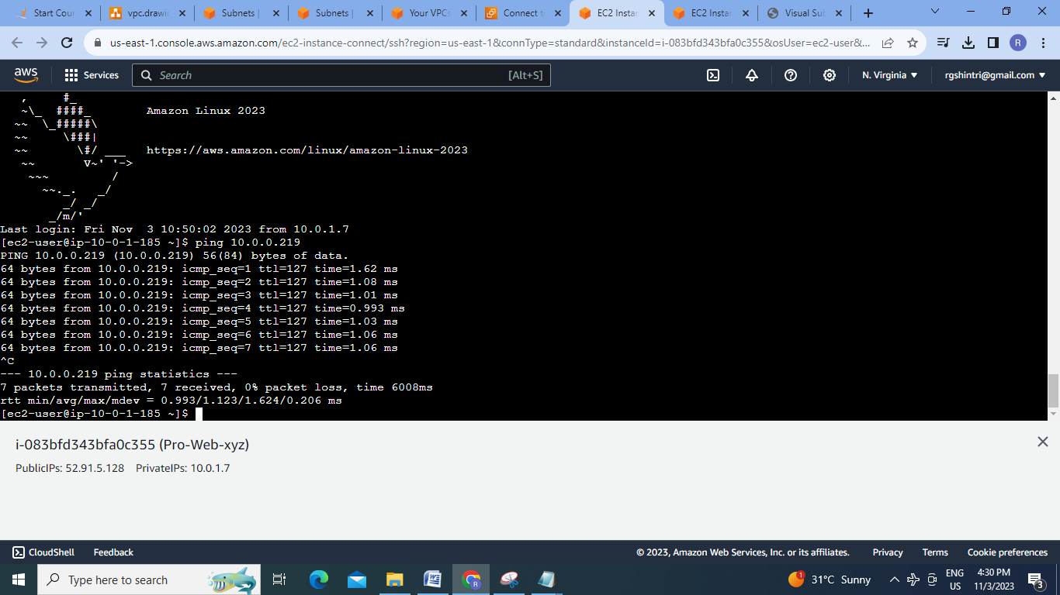

**Conclusion:** In this assignment two separate VPC’s are created i.e. Production VPC with 4 tier architecture including one public & 4 private subnets & development VPC with 2 tier architecture including 2 subnets . VPC peering connection is also established between Production Db subnet & development Db subnet.

